**Assignment-2**

Material Science

*18CH10071, Anshuman Agrawal*

**Q.1)**

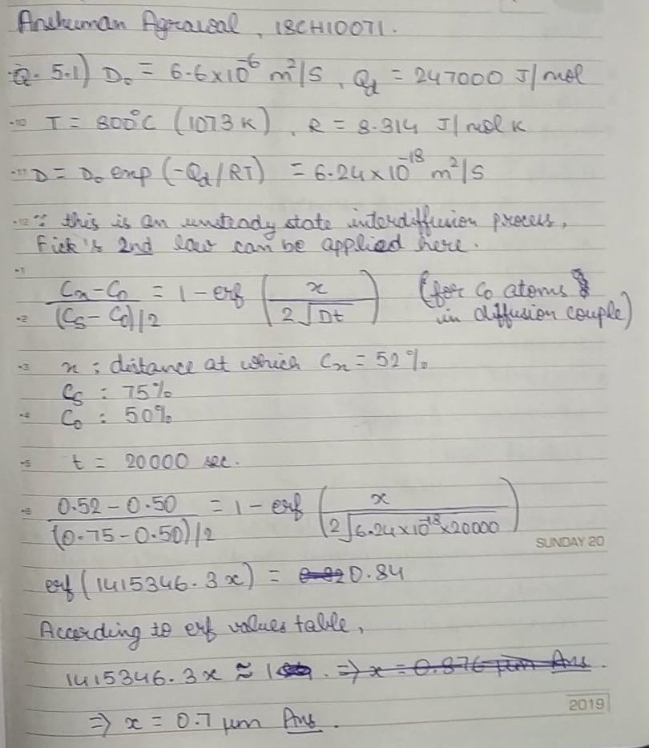

**Q.2)**

I will be looking into one of the fabrication techniques for ceramics, called powder pressing. This is an analogous process to powder metallurgy for ceramics. Generally speaking, this fabrication technique involves making a desired compact shape from the powders by applying pressure. This powdered mass also contains a binder (usually water) to act as a lubricant for the powder particles as they move during the compaction process. An advantage here is that, the powder particles do not experience plastic deformation that can possibly occur in metal powders while performing powder metallurgy. The 3 types of powder pressing techniques are as follows:

* Uniaxial: It is done using a die/ punch setup. The steps involved in this process are:

1. Filling die cavity with powder
2. Pressure applied on top die to compact the powdered mass
3. Bottom punch rises as a reaction to it thus ejecting the compacted piece
4. Fill shoe (used to fill the die cavity with powder) pushes compacted piece away and then the process is repeated.

* Isostatic: The powdered material is confined in a rubber envelope and pressure is applied on it equally from all directions (isostatically) by a fluid. This allows for more complicated shapes to be made but is on the expensive side when compared to uniaxial.

The above 2 techniques are followed by a process called sintering. It’s a firing operation done below the melting point of the ceramic material so as to prevent formation of liquid. It is done to coalesce the powder particles and reduce the porosity to a negligible amount. The driving force behind this process is a decrease in total particle surface area. Diffusion drives this process as particles move from the bulk to the neck region.

* Hot-Pressing: Powder pressing and the heat treatment are done simultaneously here, since the powdered mass is compacted at a higher temperature. This is mostly used for materials that don’t turn into liquids that easily except for very high and unattainable temperatures. It is also used where less graining is desired with higher density of the substance. This process is on the more expensive side as compared to the two techniques above.

Scanning Tunnelling Microscopy is a prevalent characterization technique to study various properties on surfaces of different substances. In this technique, a sharp metal tip near the surface of the ceramic and then an electric voltage is applied to it to view the surface at the atomic scale. This process is applied for conductive ceramics and works on the principles of quantum tunnelling of electrons.

Scanning Electron Microscopy is another method used to characterize the microstructure of ceramic materials. It produces the image of a sample by scanning the surface with a focused beam of electrons. Electrons interact with atoms at various depths within the sample and are scattered and then detected with another machine.